

**INDEX**

* INTRODUCTION
* OBJECTIVES OF THE PROJECT
* DATA COLLECTION
* DATA CLEANING
* PROJECT PRESENTATION
* RESULTS AND ANALYSIS
* TOOLS
* CONCLUSION

**INTRODUCTION**

In today's highly competitive business environment, effective and efficient call centre operations are crucial for maintaining customer satisfaction and driving business success. This project focuses on analysing call centre data to provide actionable insights that can optimize performance, improve service levels, and enhance overall efficiency.

The primary objective of this project is to conduct a comprehensive analysis of call centre operations by leveraging historical data. The analysis will cover various aspects, including time-based performance trends, attempt success rates, and forecasting future call volumes. Additionally, the project aims to estimate the number of agents required to handle future call volumes while maintaining desired performance levels, such as service levels and average handling times.

**OBJECTIVES OF THE PROJECT**

* **Time-Based Performance Analysis**: Understanding when the call centre experiences peak activity by analysing call volumes across different times of the day, days of the week, and months of the year. This helps in optimizing staffing schedules and ensuring that the call centre is adequately resourced during busy periods.
* **Attempt Success Rate Analysis**: Evaluating the effectiveness of multiple contact attempts by analysing how success rates change with each subsequent attempt. This insight helps in fine-tuning contact strategies and improving conversion rates.
* **Call Volume Forecasting**: Using historical data to predict future call volumes, allowing for proactive resource planning. Accurate forecasting is essential for maintaining service levels without overstaffing, thus optimizing operational costs.
* **Agent Staffing Forecast**: Based on the forecasted call volumes, the project will estimate the number of agents required to meet service level targets. This includes accounting for factors such as average handling time, working hours, and desired service levels.

**DATA COLLECTION**

First, I collect a sample data Hunt Digital Media. Check out the link to download the dataset.

I import the data in the excel file. The dataset contains the following columns: Call Id, Lead Id, Campaign Id, Advertiser Id, Hid(most possibly an internal Id), Call Status, Lead status, Agent Duration(in s), Customer Duration(in s), From calling number, To calling number, Attempt no., Created at, Updated at, Agent Id, Agent Name.

Now we have to study and clean it to perform reports to make an interactive dashboard.

**DATA CLEANING**

1. The ‘Created At’ column is not showing its datatype. We will copy the column and paste two times at the end. I changed the datatype of the first pasted column to Date and the 2nd one to time. In this way we get the Created Date and Created time.
2. We get same problem with the ‘Updated At’ column. In similar process we will extract the Updated Date and Updated Time.
3. We can extract month, day, year from the Date.

To get the day: =DAY ([@ [Created At]])

To get the month: =Month ([@ [Created At]])

1. We can extract hour from time.

=HOUR ([@ [Created At]])

**PROJECT PRESENTATION**

* We will build some performance report based on metrics like:
* Total calls (count of distinct call_sid)
* Unique leads (count of distinct lead_id)
* Calls connected (count of call_status = "Answered")
* Unique calls connected (count of distinct lead_id where call_status = "Answered")
* Leads converted (count of call_status = "Interested")
* Qualified leads (count of leads meeting advertiser criteria)
* Leads lost (count of call_status = "Not Interested")
* Average agent call duration (average of Agent Call Duration)
* Average customer call duration (average of Customer Call Duration)

To calculate the total calls, we will create a new measure:

Total calls =DISTINCTCOUNT (call_data_udpated [Call Id])

Similarly, we will make unique leads, campaigns, and advertiser.

We will create another measures for the different reports.

Unique calls connected

= CALCULATE (DISTINCTCOUNT (call_data_udpated [Lead Id]),

call_data_udpated [Call Status] = "completed")

Completed calls =COUNTROWS (FILTER (call_data_udpated, call_data_udpated [Call Status] = "completed"))

Leads converted =COUNTROWS (FILTER (call_data_udpated, call_data_udpated [Lead Status] = "Interested"))

Leads Lost = COUNTROWS (FILTER (call_data_udpated, call_data_udpated [Lead Status] = "Not interested"))

Then we will insert Pivot tables and put values in it.

* Some Charts:
* 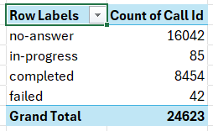Call Status distribution: I made a pivot table where fields are Call Status vs Count of Call Id. Then insert suitable charts (here I used column chart) on the basis of the table.
* 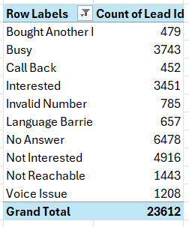Lead Disposition Report: I create a pivot table where fields are Lead Status (No answer, not interested etc.) vs Count of Lead ID. Based on the table I insert a line chart. It will help to analyse the outcomes of call attempts and improve call strategies.
* 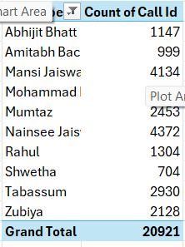A table of numbers with numbers

  Description automatically generatedCalls and Call Duration by Hour: I create a pivot table where x axis contains hour, and values are count of call id and Average of Customer Duration. It will help to understand at what time of a day how many calls are received and what is the duration of the calls. It will also be necessary to find the busy hours of the call Centre.
* Agent Performance: Here I create three visuals.

1. Calls by Agent=> x axis: Agent Name, values: Count of Call Id. It says how many calls are handled by each agent. A pie chart is inserted on the basis of the pivot table to make the visual more interesting. Here we filter the top 10 agents who handles maximum number of calls.
2. 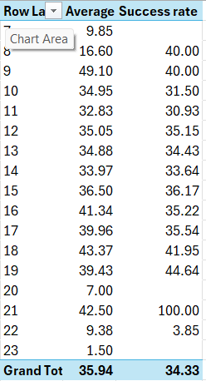Average Handling time Agent=> x-axis: Agent name, values: Average of agent Duration. It shows how much time is handled by every agent. A bar chart is inserted on this data.
3. Agent Performance=> To make the pivot chart I have to calculate a new measure called Success Rate= [Completed calls]/ [Count of Call Id] *100. Now axis: Hour, Values: Average of Agent Duration, Success rate. A clustered column chart is made on the basis of the data. This helps to understand when we have more numbers of call frequencies and also the success rate. It is very important to improve the strategy.

This can also be categorized as Time-based Analysis.

* A white background with black numbers

  Description automatically generatedAttempt Analysis: To see the attempts by Campaign a pivot chart is made where axis: Campaign ID, Values: Sum of the attempt number. It shows which campaign has the most attempts. It is displayed with a column chart.
* Success Rate: To check the success rate according to attempts, I make a donut chart. It helps to analyse the Call Status to see which attempt number typically results in a successful call.
* Forecasting Objectives:
* Call-Volume Forecast: First we need to extract the date from data. Then create a pivot chart, where Row Labels: Date, values: Count of call id. Now we have to add the dates till which we want to see the forecast. Then we get the forecasted value with the help of this formula: =FORECAST (x, known_y's, known_x's). Then we add a suitable chart on the data. We can add trendline at the chart.
* Lead Conversion Forecast: It’s objective is to estimate the number of leads that will be converted into interested prospects over the next 30 days. Here row labels: Date, Values: Count of lead id. Then we have to filter it where the lead status is Interested. Now we go to Data 🡪 Forecast 🡪 Forecast Sheet, where we can format according to our needs.
* 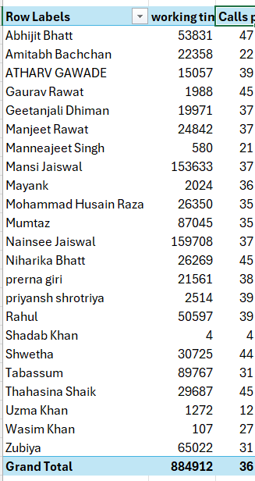Agent Efficiency Forecast:

We find the agent workload capacity. We have to create two new measures.

Working time =SUM (call_data_udpated [Agent Duration(seconds)])

Calls per agent = [working time]/ [Count of Call Id]

Now putting these two with agent name to the Pivot table we will check the Workload capacity.

To see the forecast, I create a chart of agent workload capacity, calls handled by them according to dates.

* Dashboard:

We have to put all the charts and metrices in the dashboard.

Then we have to give a suitable name with the help of text box.

At last, we need some slicers to make the dashboard more interactive. Here we create three slicers: Call status, Lead status and Month. The charts and data will change according to our selection.

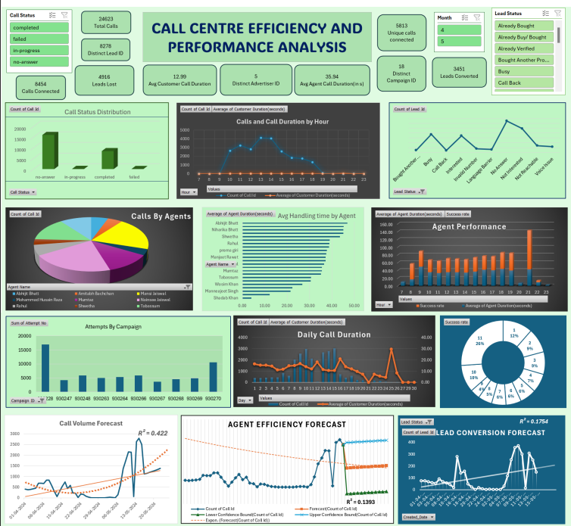

**RESULT AND ANALYSIS**

1. The number of no answer calls are highest, then the completed calls. Failed calls are least in number.
2. 1PM and 2PM are busy hours, most of the calls are done at this time. The number is least at morning and mid night.
3. If we see the lead status, we can say that mostly it is no-answer and not-interested calls. Interested and Busy calls are medium in numbers.
4. Agent Nainsee Jaiswal attended most number of calls. But Abhijeet Bhatt has highest average handling time.
5. From success rate we get a good statistic.
6. The forecasts help to predict future call volumes, agent performance, success rates based on historical trends.

The analysis in this project is centred on extracting meaningful insights from the call centre data to optimize operational efficiency, improve customer service, and make informed strategic decisions. The insights derived from this analysis will not only enhance the operational efficiency of the call centre but also contribute to better customer experiences by ensuring timely and effective service. Ultimately, this project aims to provide a data-driven foundation for strategic decision-making in call centre management.

**TOOLS**

* Google Chrome: Data collection from online website
* MS Excel: To clean the data, make the pivot tables, Creating Dashboard.
* MS word: To write the project.

**CONCLUSION**

The analysis will provide a comprehensive understanding of call centre operations, from daily performance trends to long-term forecasting. By identifying patterns, inefficiencies, and opportunities for improvement, the analysis will support data-driven decision-making, helping the call centre to enhance its operations, better meet customer needs, and achieve its business objectives.

The insights gained from this analysis will guide future strategies, helping the call centre to adapt to changing demands and maintain a competitive edge in the industry.